OBSERVATION1:

Sort and filter option is not there in customer name, invoice no and status but it should be there as per US.

Wireframe:

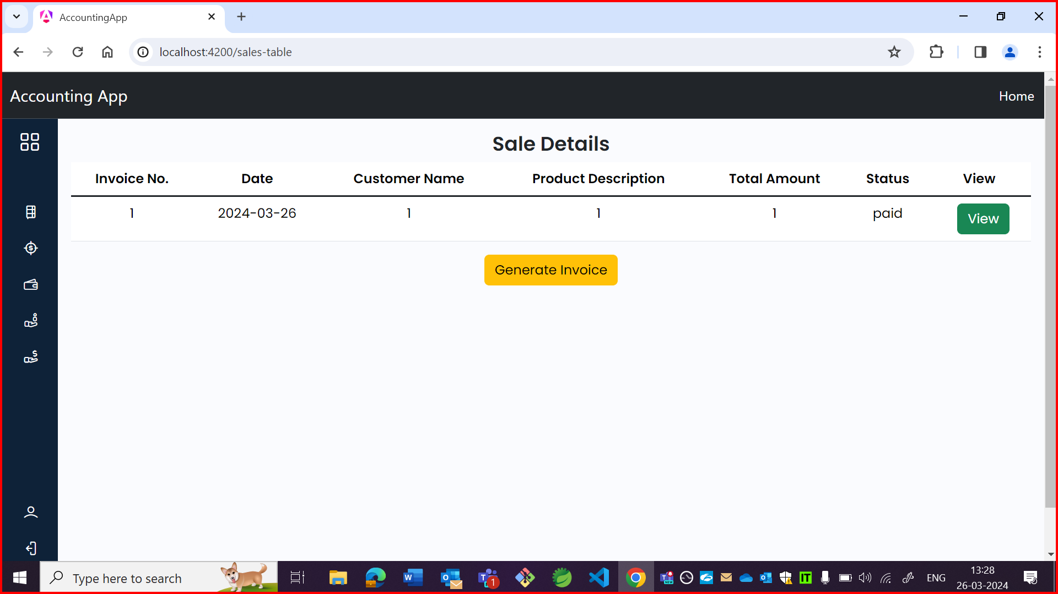

App:

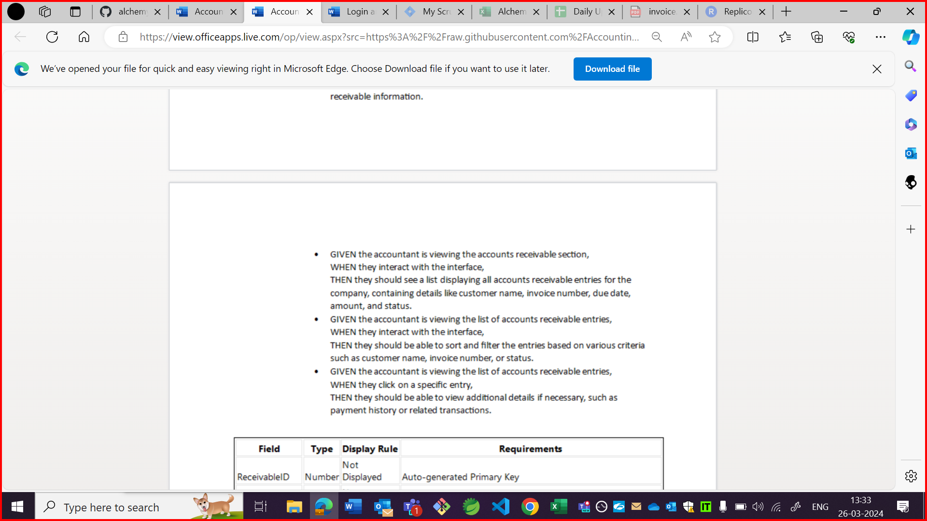

OBSERVATION2:

It is Sales in wireframe but sales details in application.

Wireframe:

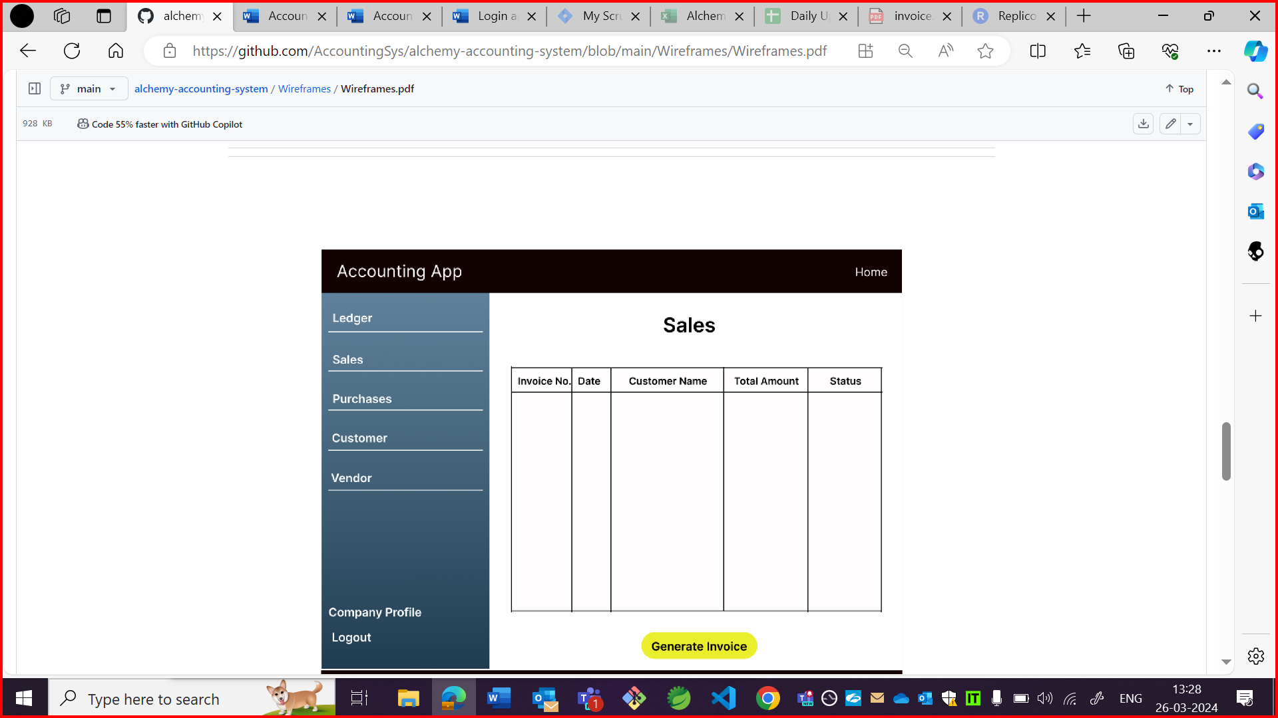

App:



OBSERVATION3:

Data is not in tabular format in application.

Wireframe:



App:



OBSERVATION4:

It is also accepting future date in invoice details.

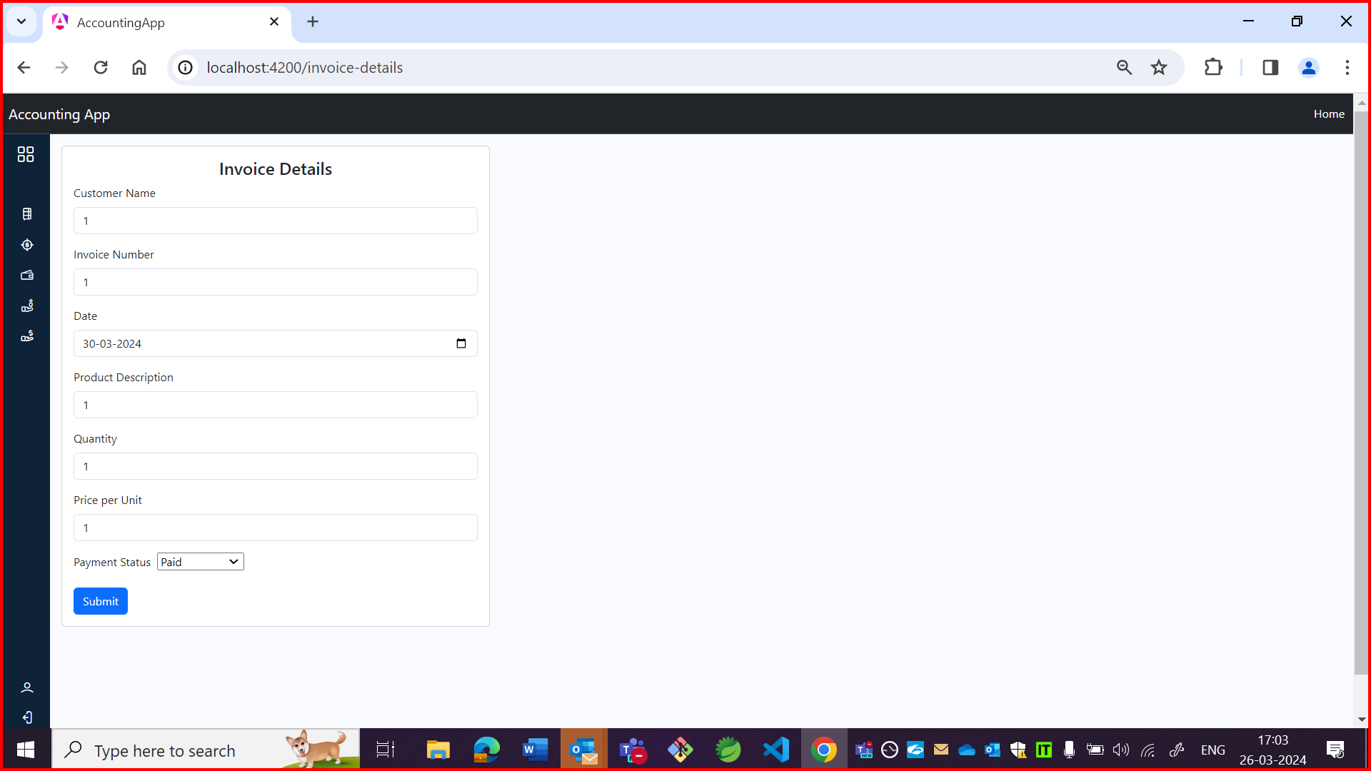

OBSERVATION5:

Field name should be due date as per US but it is date in app.

App:

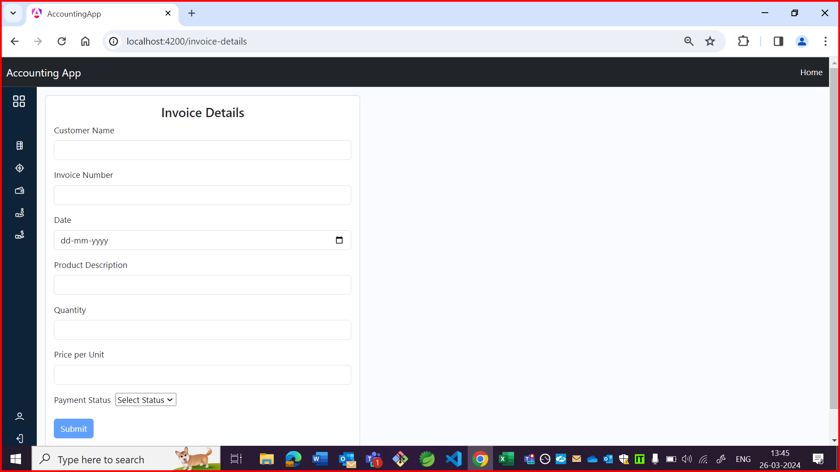

US:

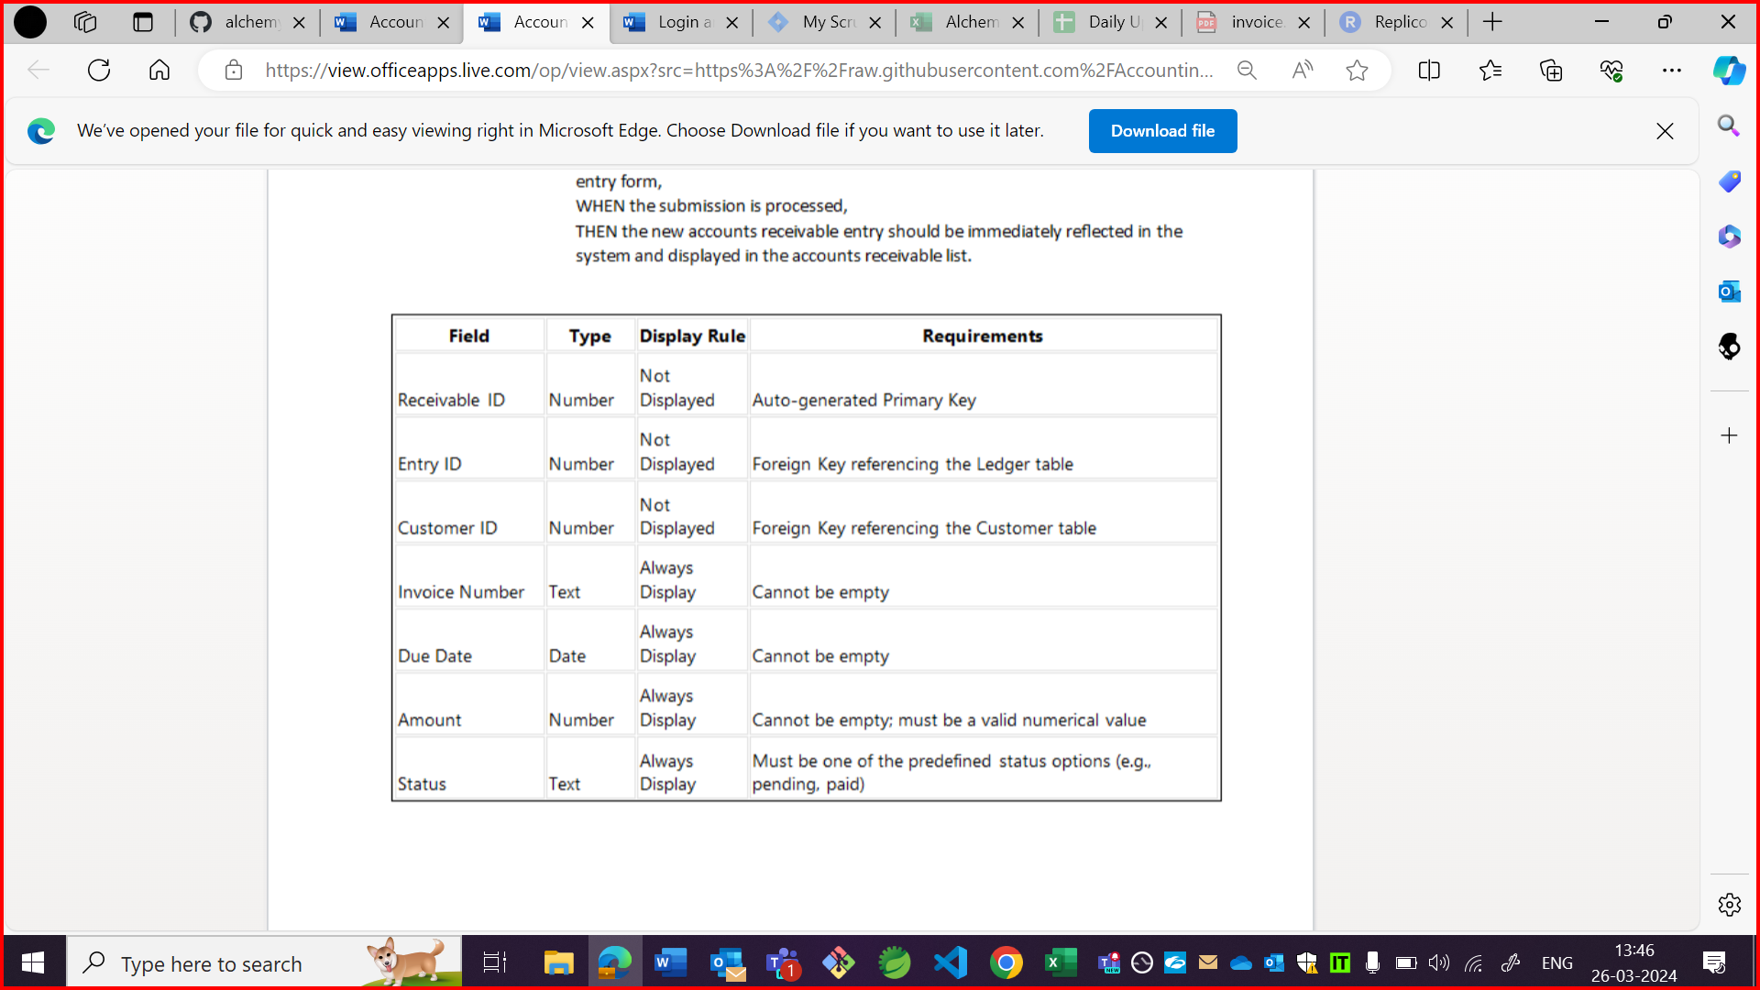

OBSERVATION6:

It should be customer dropdown as per US but it is customer name and dropdown option is also not there.

US: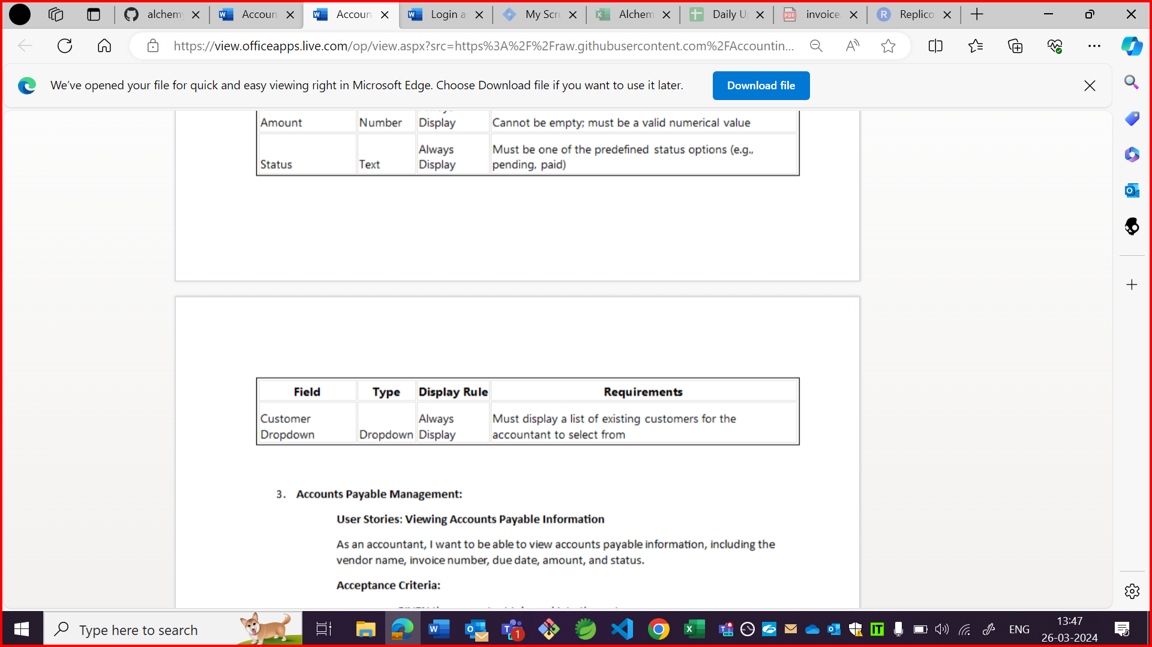

Wireframe:



OBSERVATION7:

Generate invoice form is not centre aligned.

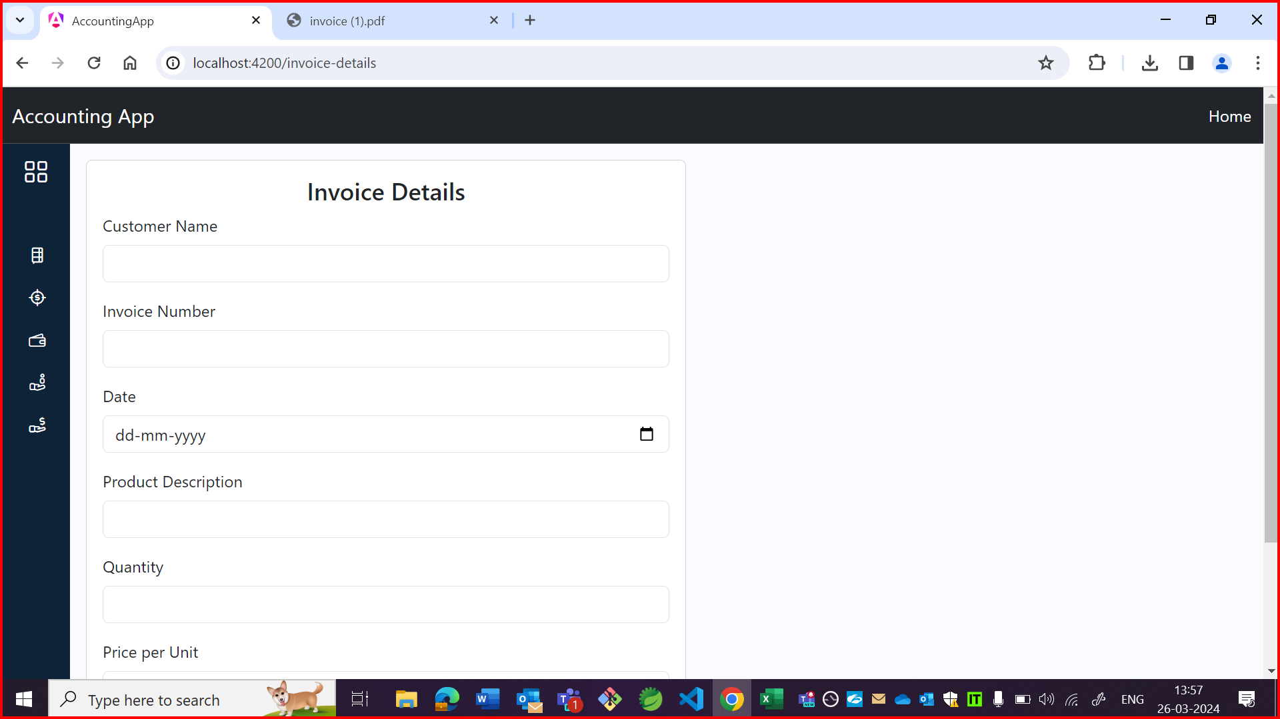

OBSERVATION8:

It should be generate button as per wireframe but it is submit button in application.

Wireframe:

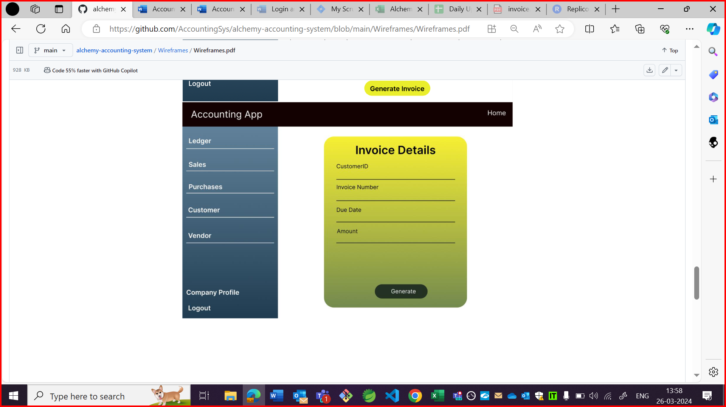

App:

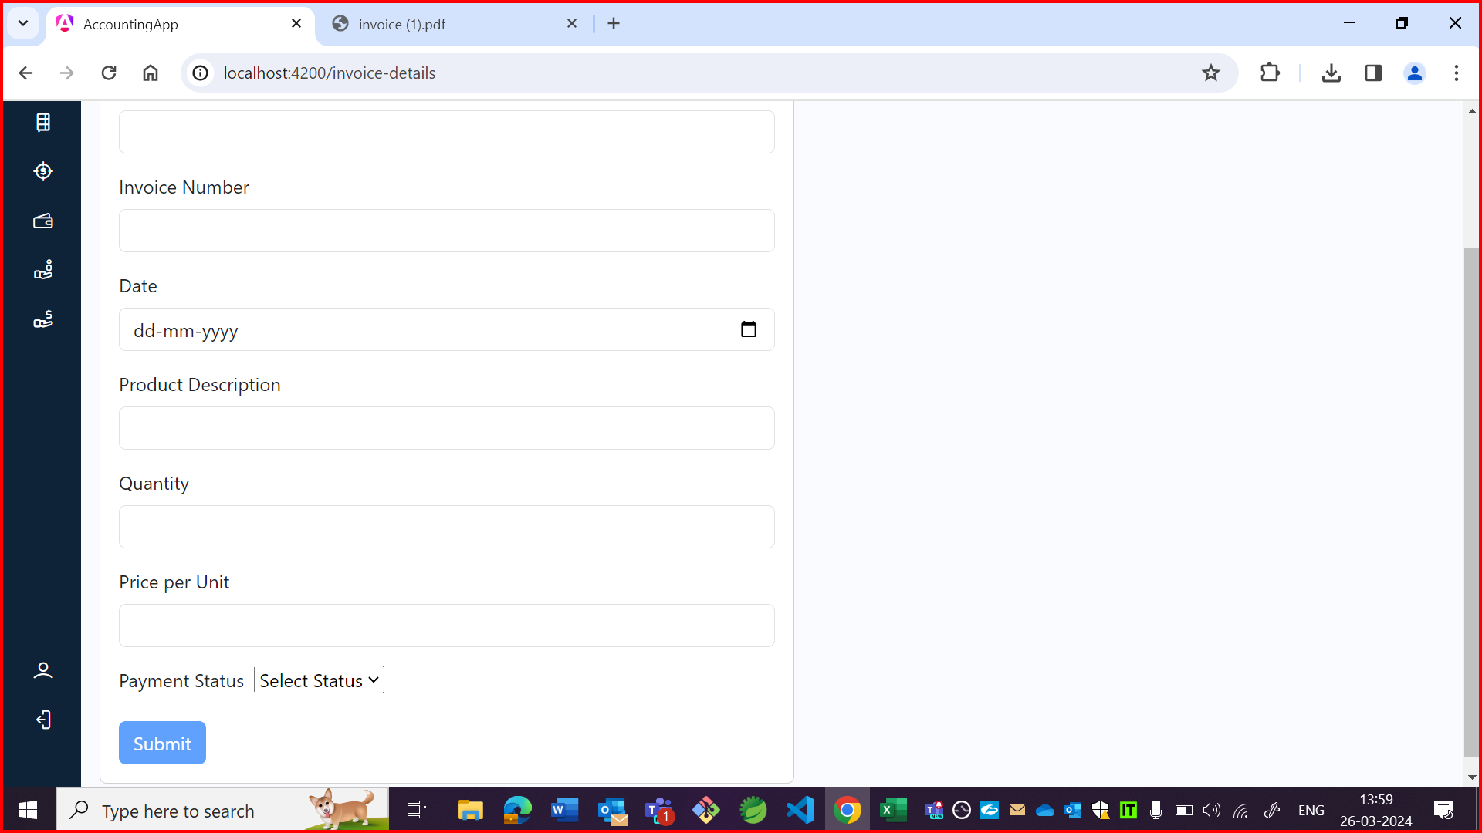

OBSERVATION9:

Whenever clicked on home/accounting app instead of going to homepage it is redirecting to sign up page.

